LAB EXPERIMENT RECORD
SET 22: TIME SERIES ANALYSIS
Department | AIDS
Course Code / Course Name | DSA0601 / Data Handling and Visualization
Experiment | Data Visualization using R
Name | B. Pallavi
Register Number | 192424243
Date | 15 October 2026
Day | Thrusday

AIM
To analyze monthly sales trends, examine the relationship between advertising and sales, and study autocorrelation using R.
DATASET
Month | Sales | Advertising
January | 15000 | 5000
February | 18000 | 6000
March | 22000 | 8000
April | 20000 | 7000
May | 23000 | 9000
Note: Advertising values are illustrative.
PROGRAM 1: MONTHLY SALES LINE CHART
Code:
month <- c("Jan","Feb","Mar","Apr","May")
sales <- c(15000,18000,22000,20000,23000)
plot(sales, type="o", col="blue",
xaxt="n", main="Monthly Sales Analysis",
xlab="Month", ylab="Sales")
axis(1, at=1:5, labels=month)
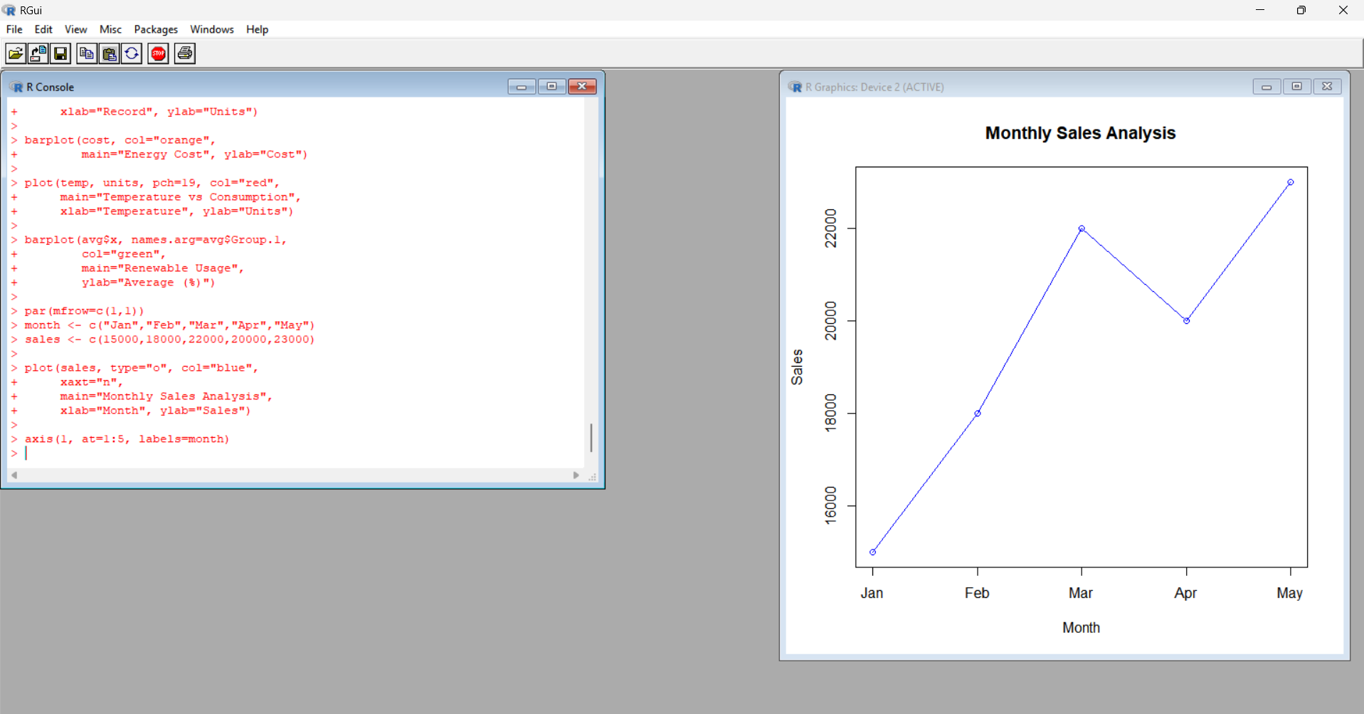
Output: A line chart displaying monthly sales.
Observation: Sales generally increase from January to May, with a decrease in April.
PROGRAM 2: ADVERTISING VS SALES
Code:
advertising <- c(5000,6000,8000,7000,9000)
sales <- c(15000,18000,22000,20000,23000)
plot(advertising, sales, pch=19,
col="red", main="Advertising vs Sales",
xlab="Advertising Cost", ylab="Sales")
abline(lm(sales ~ advertising), col="blue")
print(cor(advertising, sales))
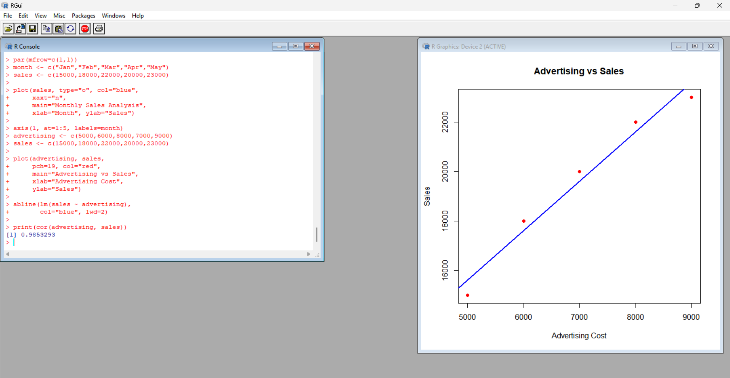
Output: A scatter plot with a regression line and correlation value.
Observation: The data show a positive relationship between advertising expenditure and sales.
PROGRAM 3: SALES SUMMARY
Code:
month <- c("Jan","Feb","Mar","Apr","May")
sales <- c(15000,18000,22000,20000,23000)
data <- data.frame(month, sales)
print(data)
print(mean(sales))
print(max(sales))
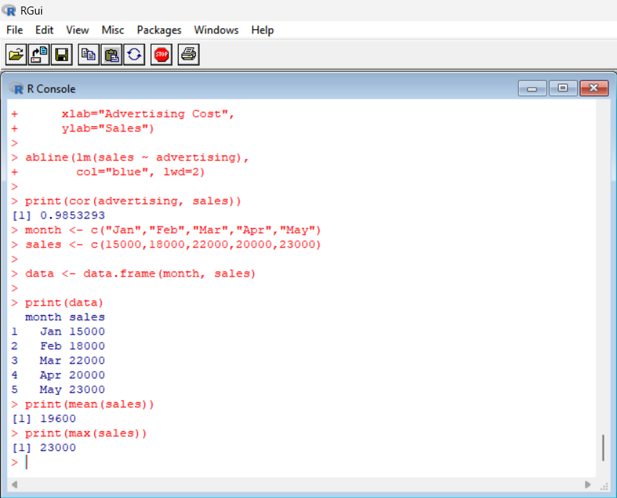
Output:
- Average sales: 19600
- Maximum sales: 23000
Observation: May has the highest sales, while January has the lowest sales.
PROGRAM 4: TIME SERIES DASHBOARD
Code:
month <- c("Jan","Feb","Mar","Apr","May")
sales <- c(15000,18000,22000,20000,23000)
advertising <- c(5000,6000,8000,7000,9000)
par(mfrow=c(2,2))
plot(sales, type="o", col="blue",
xaxt="n", main="Monthly Sales",
xlab="Month", ylab="Sales")
axis(1, at=1:5, labels=month)
barplot(sales, names.arg=month,
col="orange", main="Sales Comparison",
ylab="Sales")
plot(advertising, sales, pch=19,
col="red", main="Advertising vs Sales",
xlab="Advertising", ylab="Sales")
abline(lm(sales ~ advertising), col="blue")
sales_ts <- ts(sales, frequency=12)
acf(sales_ts, main="Sales Autocorrelation")
par(mfrow=c(1,1))
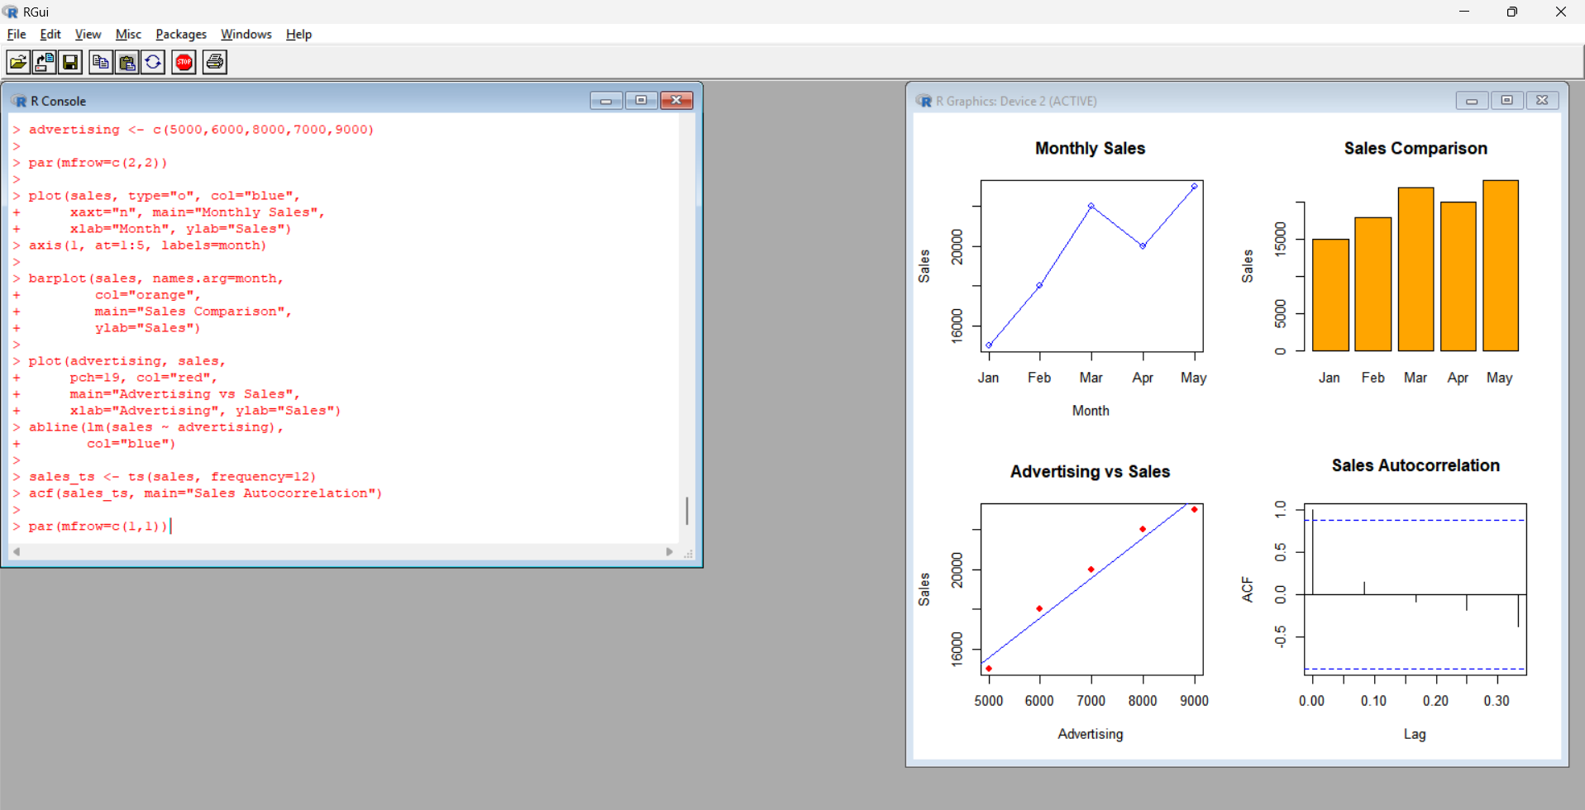
Output: A four-panel display containing a sales line chart, sales bar chart, advertising scatter plot, and autocorrelation plot.
Observation: The dashboard summarizes sales trends, advertising relationships, and autocorrelation. Five observations are insufficient to establish a reliable seasonal pattern.
RESULT
Monthly sales trends were visualized, the relationship between advertising and sales was examined, summary statistics were calculated, and a time-series dashboard was created using R.

